Vehicle monitoring terminal ZH900 series

User manual

Acknowledgement

Welcome to be the user of ZH300 series of video surveillance terminals. If this manual can provide you with help and convenience, we will be very pleased. If you encounter problems in the process of use, or have good Suggestions for our products, please contact us, to you in the use of the problem, we will give support, to your Suggestions,we will seriously rectify
Introduction

Writing purpose

The User manual of ZH Series products may not be technically valid or misprinted. The contents of this manual are updated regularly without prior notice. If the description of the products in the manual is inconsistent with the facts, all the actual products shall prevail.

Safety warning

In order to enable users to use this series of products in a long-term, safe and satisfactory manner, please read the following warnings before installing and using the products：
①.All installation and maintenance must be performed by professional and technical personnel
②.The normal working voltage range of the equipment is DC 10V~33V. Please pay attention to the power input and the stability of the power input circuit. The output cannot be short-circuited.。
③. The device outputs a 12V voltage externally, which is only used for camera power supply, and no non-recommended equipment should be connected
④. Correctly connect the ground wire of the device to the ground wire of the vehicle to form a loop
⑤. The equipment should be installed in a dry and ventilated environment, avoid moisture, rain, and the vehicle's clean flush position, and keep the equipment away from heat sources, dust and strong magnetic fields
⑥. Please install the equipment on the vehicle where the vibration is weak as much as possible to improve the stability of the equipment and extend the service life
⑦. No sundries can be stacked within 20cm around the installation equipment, and no heavy objects can be placed under pressure to ensure a heat dissipation environment
⑧. The storage devices and modules on the device do not support hot swap. Please do not plug and unplug the storage devices or modules when the device is powered on.
⑨. Please regularly maintain the SD card of the storage device: copy the video data to the computer and format it.

Introduction

product description
The V300 series of products is a cost-effective and extensible device specially developed for vehicle video surveillance and remote monitoring. It adopts high-speed processor and embedded operating system, combined with the most advanced H.264 video compression/decompression technology, network technology, and GPS positioning technology in the IT field. V300 series products can realize 8 channels of 720P full-frame recording, 4-channel 1080P 15-frame video, five recording formats of CIF/HD1/D1/720P/1080P can be selected, local recording and wireless data uploading, car driving information recording, and central software can realize central monitoring and remote management of alarm linkage And playback analysis, committed to the direction of car networking，

Product features

Specification

System | OS | Linux
Video | Input | 8 channels AHD(1080P)
Video | Output | 1 channel
Video | Total Resource | 8*720P@25fps(AHD) or8*1080P@20fps(AHD)
Video | Video Signal Standard | Electrical level: 1Vpp Impedance: 75Ω NTSC/PAL Optional
Audio | Input | 8channels
Audio | Output | 1 channel
Audio | Audio Signal Standard | Electrical level: 2Vpp Input impedance: 4.7kΩ
Display | Display Split | 1-8
Display | OSD | GPS information, alarm, vehicle No., speed, date/time
Recording | Video/Audio Compression | Video: H.264、H265
Recording | Video/Audio Compression | Audio: G.711A,
Recording | Image Resolution | Analog:  PAL:  1080P(1920X1080), 720P(1280X720), D1(704X576), HD1(704x288), CIF(352x288)  NTSC:  1080P(1920X1080), 720P(1280X720), D1(704x480),HD1(704x240),CIF(352x240);
Recording | Image Quality | 1-8 levels adjustable (1 is the best)
Recording | Recording Mode | Schedule/Alarm(sensor trigger, speed, acceleration, video loss, temperature)
Recording | Pre-recording | 0-60 Secend
Recording | Post-recording | 0-60 minutes
Recording | Mirror Recording | Yes
Network | WIFI/3G/4G(choose one or more from list) | 802.11b/g/n/ac/EVDO/TD-SCDMA/WCDMA/TDD-LTE/FDD-LTE and so on
Locating | GPS | Location tracking, speed detection and time sync
Storage | SD | SD card slot x 2(Default 1)
Interface | USB | USB2.0 x 1
Interface | RS485 | RS485x1(optional)
Interface | RS232 | RS232 × 2(optional)
Interface | SIM | SIM Slot x 1(optional)
Interface | Sensor | 4 inputs, 1 outputs
Power | Input | DC10-33V
Power | Output | 12V@2000mA
Power | Max Power Consumption | 36W
Physical Characteristic | Dimension (L × W × H) | 148mm x 138mm x 35mm
Physical Characteristic | Weight | 480g
Environment | Operating Temperature | -20℃- +70℃
Environment | Operating Relative Humidity | 8%~90%(No Condense)

Out-of-product characteristics

3.1 accessories list
S.N. | Ltem | Image
1 | Device | 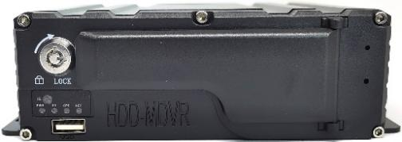
2 | Power cable
3 | 4G antenna | 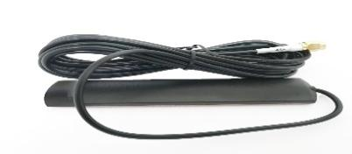
4 | GPS antenna | 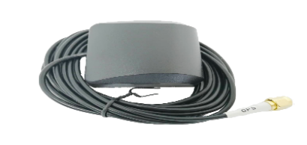
5 | Remote
6 | Key
7 | IO cable
8 | User manual
9 | Video cable

Host appearance diagram

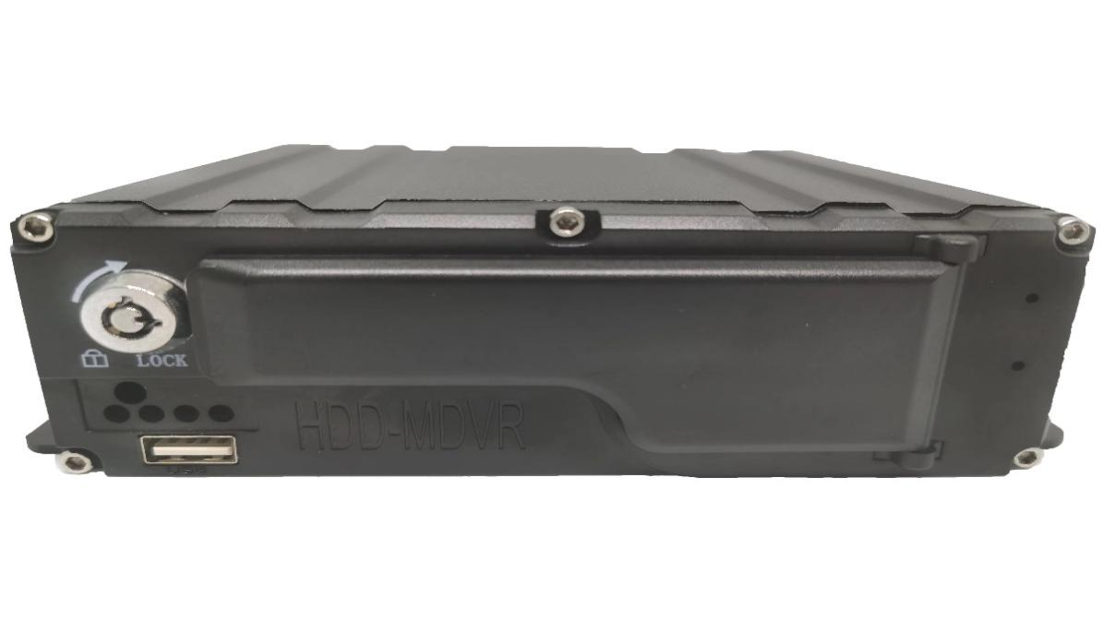

  - Machine size and mounting hole position（UNIT：mm）

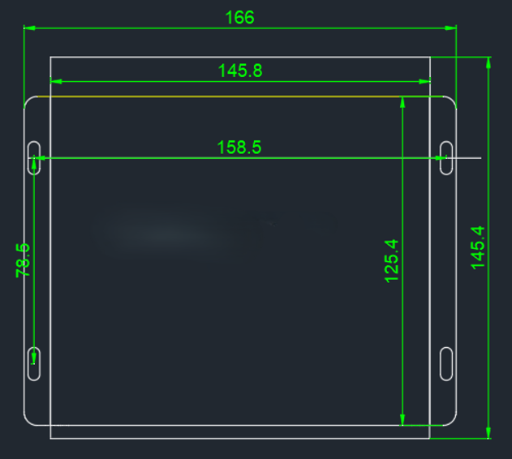

Front panel interface and indicator light

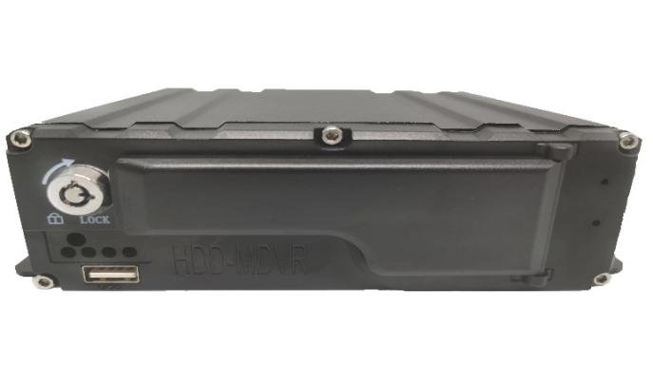

The front panel interface and indicator light are defined in the following table：
classification | project | define
Interface | HDD  SIM | The maximum capacity of the hard disk is 2T  4G card, dial-up Internet access
Indicator light | GPS  PWR  SD  NET | GPS indicator light, flashing when GPS module has no signal;  The light is always on when the signal is normal; No module light off detected  Power light, red, power input light is always on  SD card indicator light, green; Video, flashing; No SD card detected Video, often bright; SD card not detected, light off.  4G dialing status light, green; There is an unconnected server light flash in 4G module; Connected to the server successfully, the lamp is long on, but the module lamp is not detected
IR | Infrared receive | Receiving remote control button
Electronic lock | LOCK | SD card and SIM card baffle lock, do not lock the host can not start, hit  Automatic standby state of the host machine 5 seconds after opening the lock

ack panel interfaces and definitions

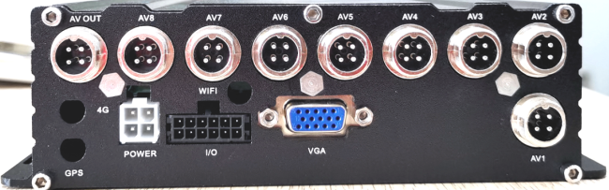
SD card video recorder rear panel

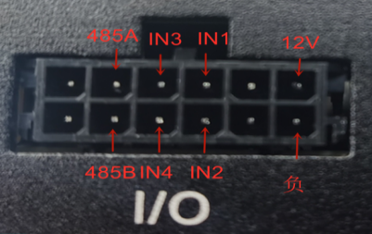

Video interface definition diagram：
Audio and video input and output (AV_IN1~AV_IN4, AV-out) interface definition diagram
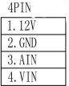


Back panel description：

interface |  | define
AV—IN1~AV—IN4 |  | Four - way camera audio and video input interface
AV—OUT |  | Audio and video output interface
VGA |  | Hd video output interface
4G |  | 3G/4G antenna interface
GPS |  | Locate module antenna interface
IO |  | 4 channels IO input, 2 channels alarm output, 1*RS485 interface or 1*RS232
POWER |  | Power input interface, DC10-33V
WIFI | WiFi Antenna Interface

Host operation guide

4.1 Main Menu Tree

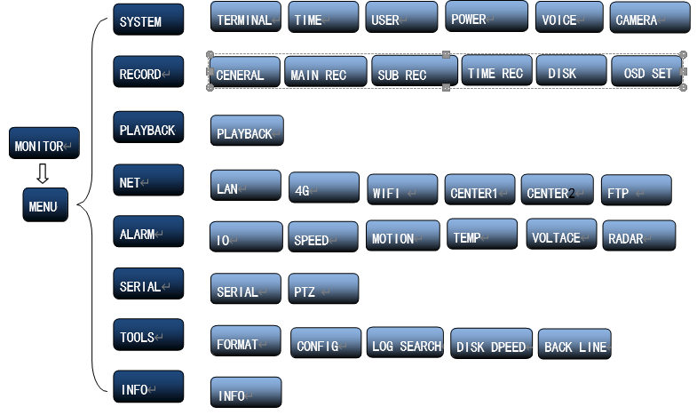

4.2 Remote control function key guide：
【OK】 | Enter
 | Video playback pause and start
PLAY | Start play button
EXIT | Exit and return to the previous submenu
DEC | Delete key and backspace
PTZ | PTZ button
LOGIN | When the recorder has a password, press LOGIN key can enter the password
 | Power
0-9 | 0-9 corresponds to the channel number | 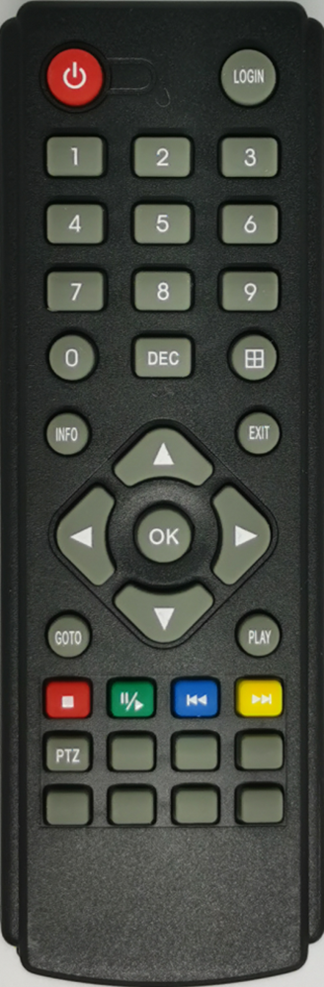
INFO | Can view module status, Alarm status, system message
田 | Can switch single screen four screens, nine screens
 | Up, down, left and right arrow keys  The left and right arrow keys have both playback video  Fast forward and fast rewind function,

  - System operation and settings

4.3.1 Boot preview

The system time is displayed when the system is turned on, and each channel displays the channel name, and the red dot is the recording mark, which means that it is recording.。
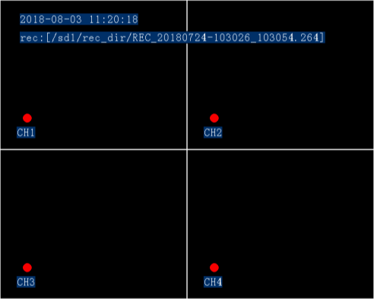
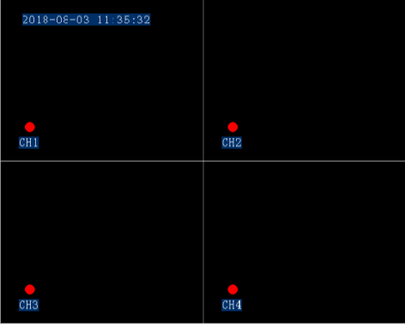

    - User login

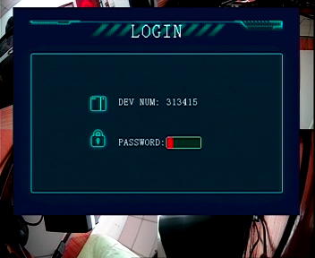

- The password switch is turned on, and the login menu will pop up by pressing the login button.；
- The default administrator password: 666666, the default password for ordinary users: 000000；
- The password switch is closed and the login interface will not pop up.

    - System operation and settings

Description：

All sub-menu settings must take effect after [Save]

Back to the preview screen, the device starts recording。

Some parameter settings need to be restarted to take effect。

Digital input can be directly input by pressing the number keys on the remote control. Character and pinyin input using software disk

Main menu: system settings, video settings, video playback, network settings, alarm settings, peripheral management, management tools, system information
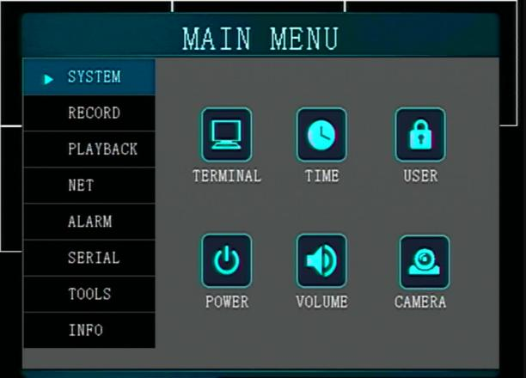

System：：Terminal

settings, time settings, user management, switch machine settings, volume settings, camera settings

Terminal Settings: vehicle information, report platform vehicle ID, information；
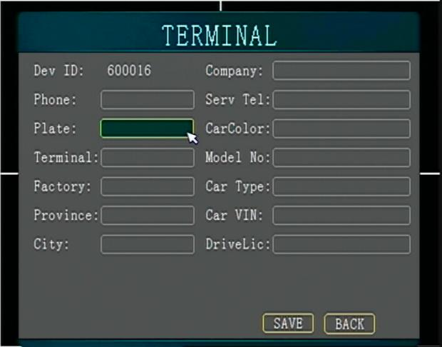
- Device number: display device serial number

- phone number： Report the sim card number of the monitoring platform 2
- Input method: Press the OK key to bring up the small keyboard, which can input Chinese, letters, numbers and punctuation marks。

Time Setting:
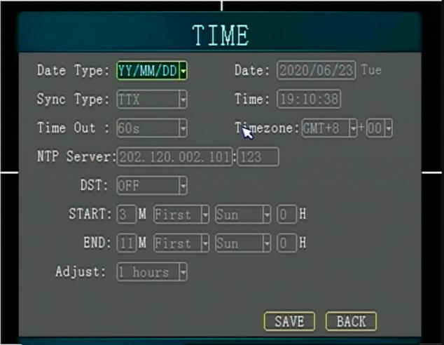

- Date Format: year/month/day, month/day/year, day/month/year, press [OK] to switch
- Date And Time: display according to the selected date format, manually proofread with the number keys

- Time Zone: A metaphor for China's East Eighth District, GMT+8。
- Automatic Time Calibration: GPS/NTP/off, GPS: GPS has signal, the system time has error, automatic time calibration;Platform, connect to the platform to automatically adjust the time

- NTP Server: set the network server for NTP time calibration。
- Daylight saving time: turn on/off, set daylight saving time according to different regions；
- Operation timeout: Return to the preview screen if there is no remote control within the set time
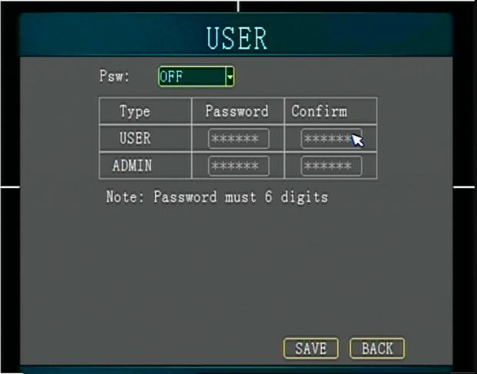
User management: login password setting

- Enable: open/close
- Set the user password and the administrator password respectively: the default administrator password: 666666; the default user password: 000000.
The administrator password has all permissions, and the user password only has the viewing function and cannot set parameters

Switch machine settings：
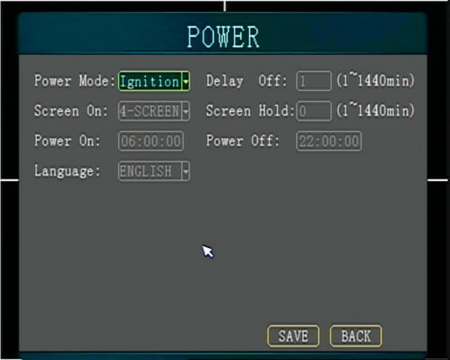

- Switch mode: ignition mode/timing mode/standby mode
- Ignition mode: the car key control device turns on and off, the car key turns on the device to start
- Timing mode: the device starts to work normally at the boot time, and the device stops working at the shutdown time and enters the standby state
- Standby mode: After the delay time of the ACC closed state, keep the terminal 4G and GPS online, but do not record
- Delay time: The delay time is only enabled in the ignition switch mode. After the car key is turned off, the device will enter the standby state after a long time delay in normal operation

Volume setting：
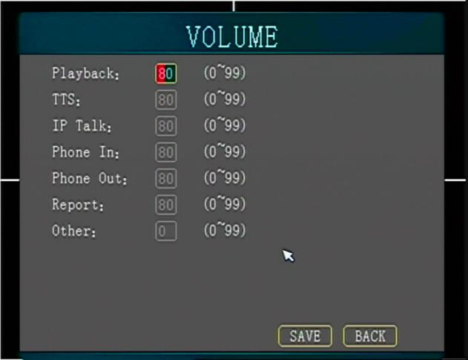

Camera settings: set the video direction and picture effects;。
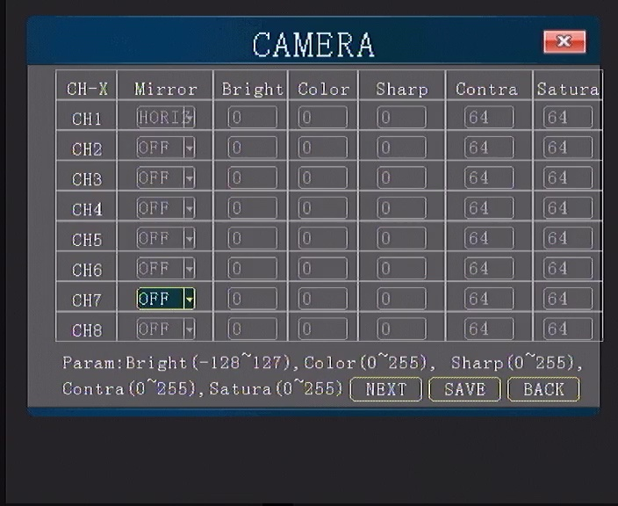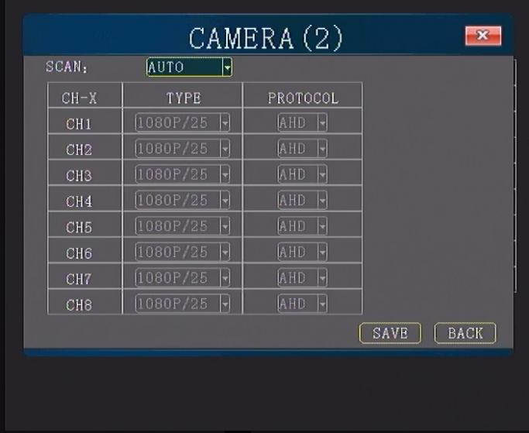

. Video settings: basic settings, main stream settings, sub stream settings, timing settings, storage management, OSD settings。
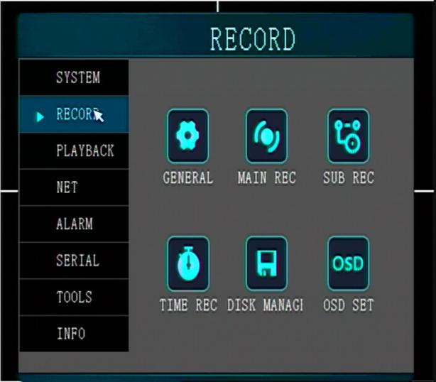

Basic setting: basic recording parameter setting
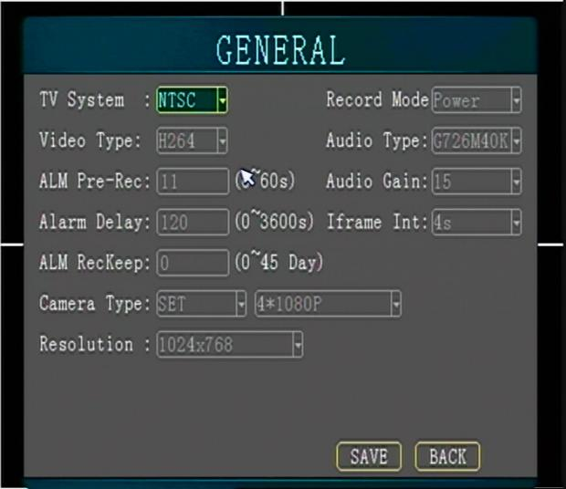

- Video format: PAL, NTSC, press【OK】key to select from the drop-down menu。
- Video mode: boot video, timed video, alarm video, Start-up recording: start recording automatically when the device is turned on；Timing recording: start recording during the set timing recording time period, and not recording at other times. Alarm recording: the device starts recording when an alarm is generated
- Audio format: G726-M40K/G726-M32K/G726M40K/G726M32K/G711A
- Audio gain: 0-14 levels optional, adjust the volume。
- Alarm pre-recording: record a period of time before the alarm
- Alarm delay: the recording will continue after the alarm is removed, and the recording time is the set time
- Alarm protection: In the video file list interface, select the video file to lock, it will not be automatically overwritten during the alarm protection.
- Camera type: Choose according to the camera resolution。

Main stream setting: setting of recording parameters for each channel
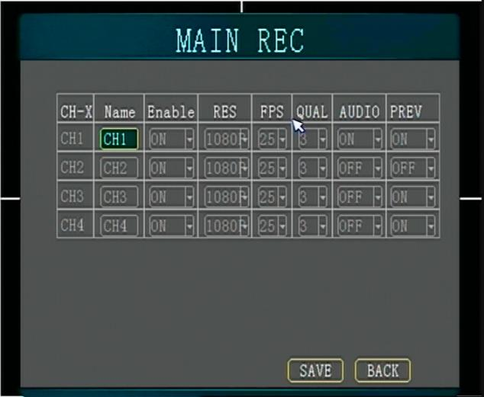

- Channel name: preview and playback screen will be displayed

- Main recording: On: means the channel has the recording function on；

Off: means that the channel does not record,

- Resolution: 720P, D1, HD1, and CIF can be selected. For example, under PAL system: 720P resolution is 1280*720, D1 resolution is 704*576, HD1 resolution is 704*288, CIF resolution is 352* 288
- Frame rate: indicates the number of video frames per second, PAL system is 1~25 frames/sec, NTSC system is 1~30 frames/sec
- Picture quality, picture clarity, 1~8 levels, level 1 picture quality is the highest
- Recording: Turn on/off,indicating whether to record audio while recording video

Sub-stream settings: set the parameters of the 4G network transmission video stream
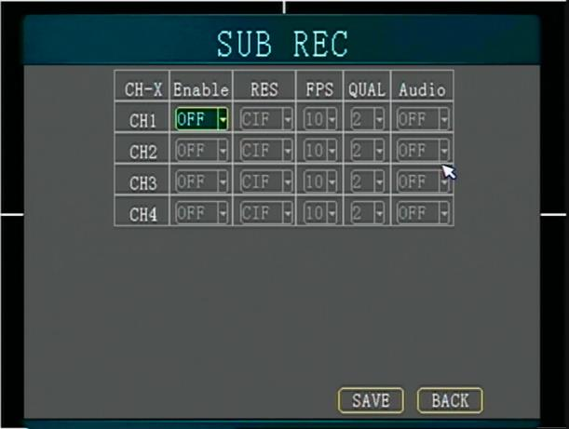
- Sub video: turn on/off, whether to turn on the sub stream video function。
- Resolution: CIF/HD1/D1 optional
- Frame rate/picture quality/recording: same as the main stream setting interface parameters.
Timing setting: set the timing recording time period
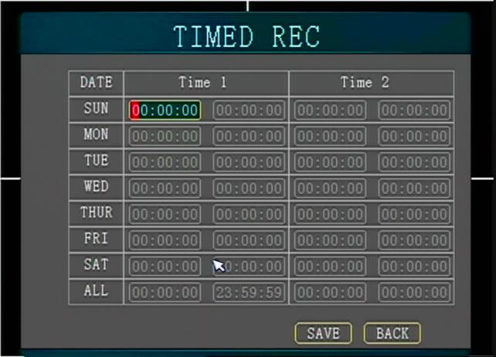
- You can set up to 4 recording time periods per day
- Date: The set time period is valid for 7 days from Monday to Sunday
- Time zone: the start time of the time zone cannot be greater than the end time

Storage management：
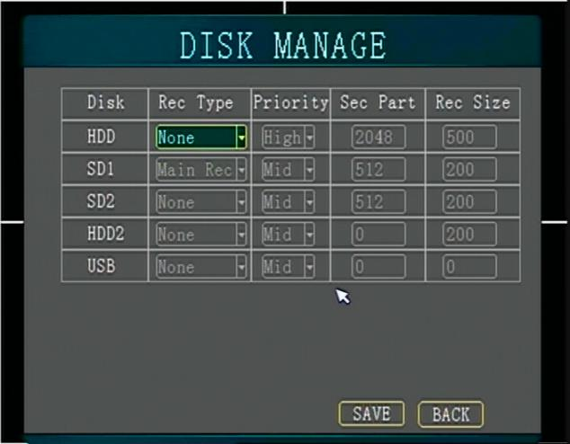
- Purpose: Optional main video/sub video, select video stream.
- Priority: high/medium/low;

OSD setting: superimposed information and display position of video recording。
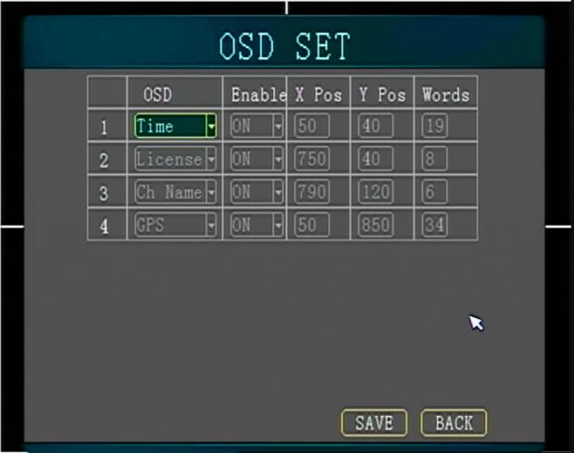
- Superimposed items: time/license plate/phone number/channel number/GPS information；
- Enable: open/close；
- X/Y coordinate: the position where the superimposed information is displayed on the screen；

. Video playback: playback the local video
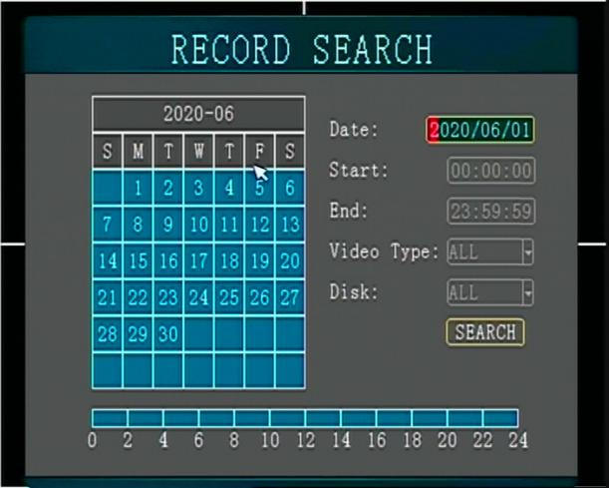
- Monthly calendar: the date displayed in green indicates that the day is normal recording, and red indicates that there is alarm recording
- Recording type: all/normal/alarm
- Storage medium: all disks/HDD/SD1/SD2/USB
- Time: You can select the date and time period to search for video files

Video file list：
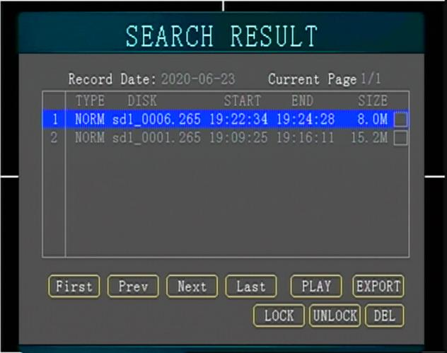

- A file includes 4 channels of video data, and 4 channels of audio and video are played back simultaneously. The interface displays the start, end time and file size of the video file.
- When there is no video input, it will still record normally, and the playback will see a black screen with date and time display.

- Export: USB access U disk, the administrator password 666666 is required to log in.
- Lock/Unlock: Manually lock/unlock the file, the locked file will be automatically overwritten after the alarm protection time has passed
- play: four-channel audio and video playback synchronously, press number 1, 2, 3, 4 for single channel full screen, press 【田】key to display four pictures

. Network settings: local settings, dial settings, WIFI settings, monitoring platform, ministry standard platform, FTP settings

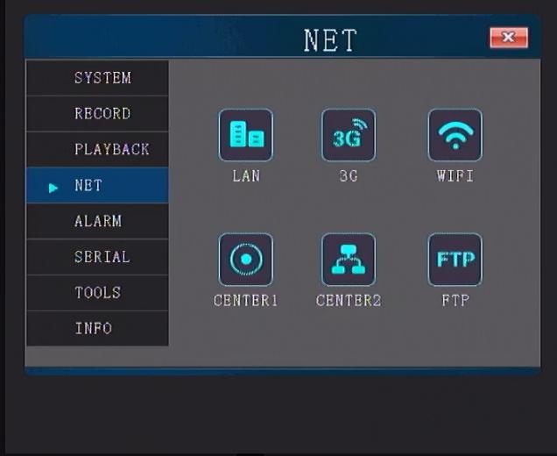

Local setting: local IP setting
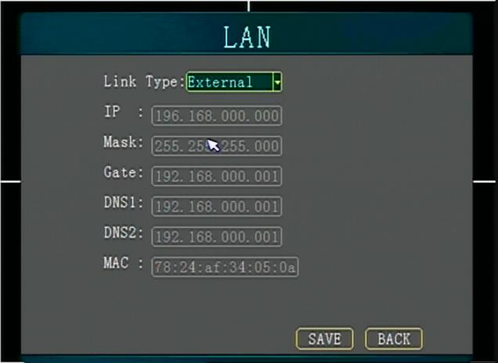

Set local IP address

4G setting: 3G/4G dialing parameter setting
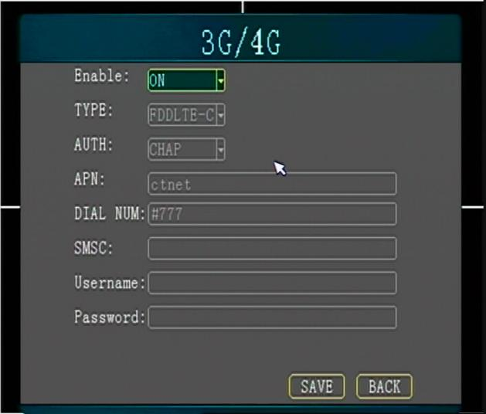
- 3G/4G dialing parameter setting, select the module type, the dialing parameter defaults to the public network dialing parameter；
- To use a private network, you need to manually enter information such as dial-up access points；

WIFI setting: WIFI module connection wireless router parameter setting
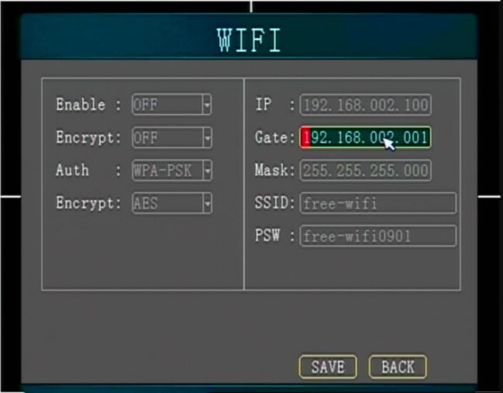
  - WIFI enable: open/close
  - Authentication mode: the encryption method corresponding to the wireless router

  - SSID: the name of the WIFI
  - Password: WIFI password
  - IP address: When using WIFI, ensure that the IP and the locally set IP are not in the same network segment. When WIFI exists, the terminal will automatically select the WIFI connection server

Server settings: Connection center server settings

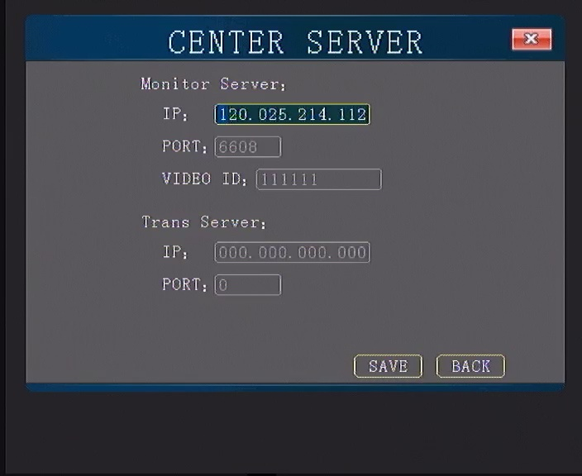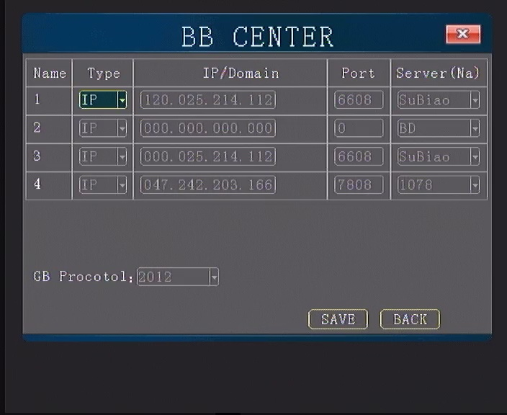

- Monitoring server settings: report the IP address of the video server (main IP connected to the monitoring center)
- Ministry standard server setting: Ministry standard protocol platform parameter setting, divided into main server and backup server, and other slaves, expansion server。

FTP settings: remote upgrade FTP server parameter settings
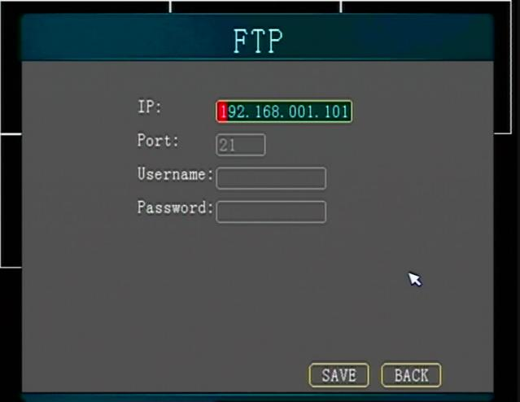
- Set the FTP server parameters, the terminal will automatically connect to the network when connected to the FTP server to detect whether there is a new version that needs to be upgraded, and the new version will be automatically downloaded；

. Alarm settings: I/O alarm, speed, acceleration, temperature, voltage ,radar
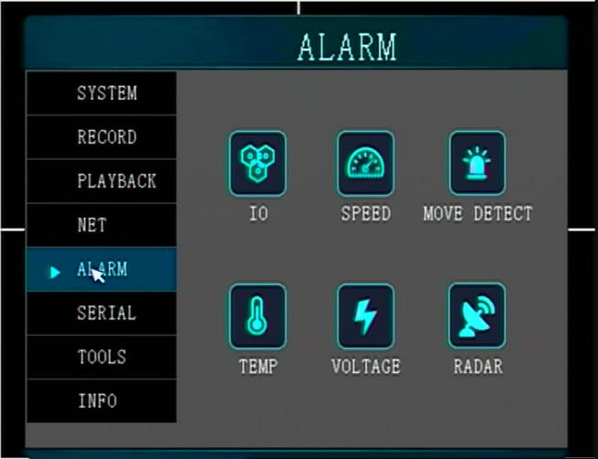

I/O alarm setting: IO line required：
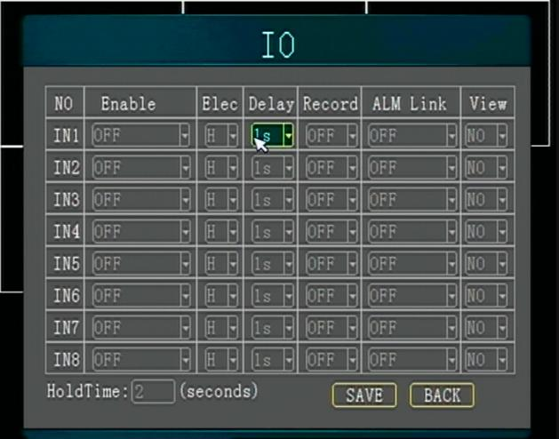
- Enable: open, detect whether there is an I/O alarm; close, do not detect whether there is an I/O alarm
- Level: low level, 0~4V; high level, 4~25V; set to low level, the device will generate an alarm when it detects a low level input; set to high level, the device detects a high level Alarm
- Delay: After the alarm is over, the alarm state will be released after a certain delay to prevent too frequent alarms. For example, the door signal of some models is pulse level。
- Video: video/photograph, whether alarm recording and photographing are required to generate an alarm
- Alarm linkage: close/output short video。
- Screen cut: zoom in a certain channel when an alarm occurs.。
- Alarm retention: the alarm will be generated after the corresponding time is reached to prevent false triggering

speed：
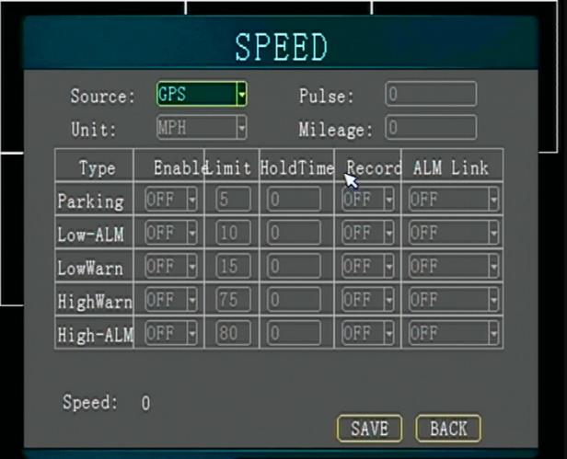

- Speed source: GPS/vehicle,
- Coefficient: Need to be set when the speed source is a vehicle

- Speed unit: Km/h, MPH

- Enable: turn on/off, whether to detect overspeed alarm
- Threshold value: set the range of super high speed and low speed

- Duration: The corresponding alarm will be generated after reaching the corresponding state to prevent false triggering。

- Video: On/Off
- Alarm linkage: close/output 1/output 2, trigger the corresponding linkage operation after alarm
- Acceleration：
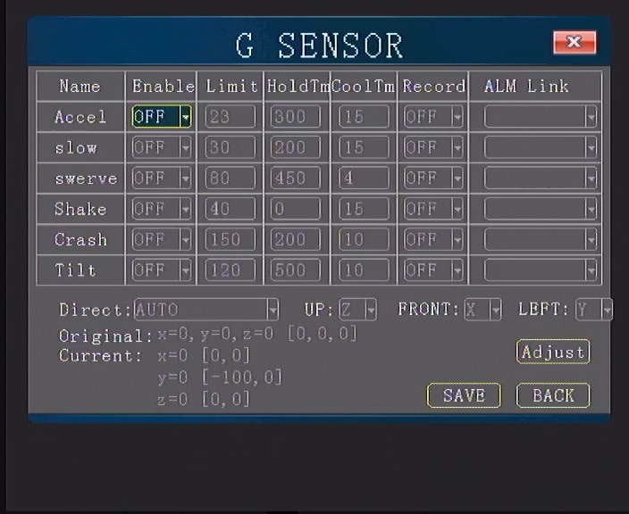
- Enable: whether to detect alarm
- Limit：An alarm is generated when the set value is exceeded
- Holdtime: The duration generates an alarm, unit：ms
- Cooltime： The alarm occurred again when the cooling time ended，unit：ms
- Record：Record a short video when an alarm is raised
- Alarm Linl ：After the alarm, upload the video to the remote server
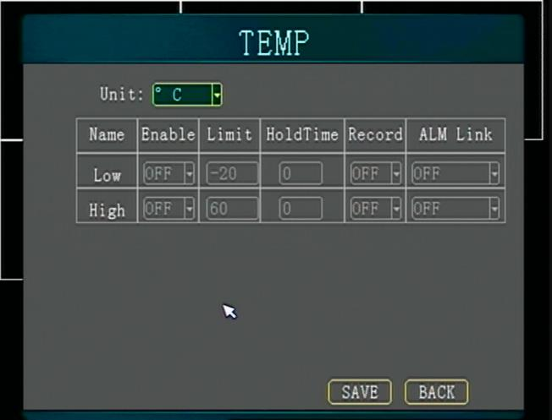 temperature：

- Enable: open/close, whether to detect temperature alarm
- Threshold value: set the range of high and low temperature alarm

- Duration: continuous low temperature and high temperature alarm

- Recording: turn on/off, whether to generate alarm recording for speed alarm
- Alarm linkage: close/output 1/output 2, trigger the corresponding linkage operation after alarm
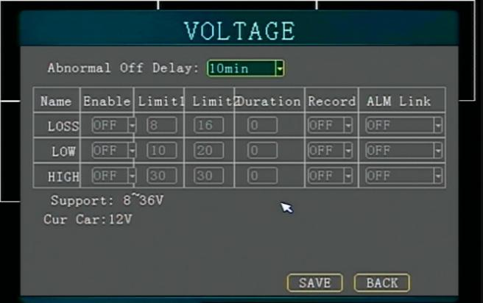VOLTAGE：

- Abnormal voltage shutdown delay: select the appropriate voltage delay time

- Low-voltage alarm: low-voltage alarm is generated when it is below the threshold

- High pressure alarm: high pressure alarm will be generated if it is higher than the threshold

- Enable: open/close, whether to detect voltage alarm

- Threshold value: set the range of high and low voltage alarm

- Duration: the corresponding alarm will be generated after reaching the corresponding state
- Recording: turn on/off, whether to generate alarm recording for speed alarm
- Alarm linkage: close/output 1/output 2, trigger the corresponding linkage operation after alarm

. Peripheral management: peripheral device PTZ and serial port settings connected via serial port

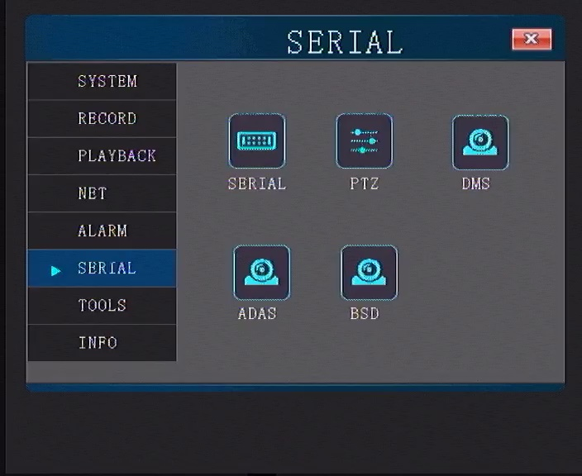•

Serial port settings: 1 RS485, 2 RS232 serial port.
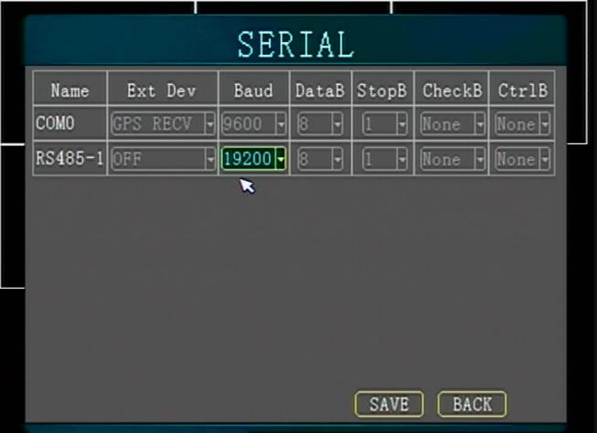
- 232 serial port: a short-distance transmission channel serial port on the terminal, (usually connected to a credit card machine, printer)
- 485 serial port: a long-distance transmission channel serial port on the terminal (generally connected to the PTZ)

PTZ: PTZ parameter settings

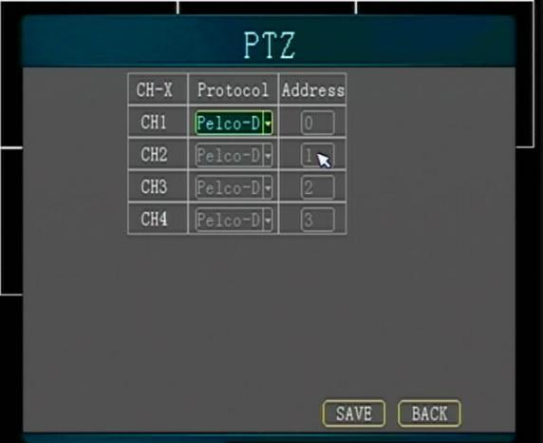

- Currently only supports two protocols: PELCO-D, PELCO-P, according to the specific PTZ。
- PTZ Operation: After setting the PTZ parameters, return to the direct screen, switch to the channel of the PTZ screen, and press the remote control
- F2 key to enter PTZ control。

DMS
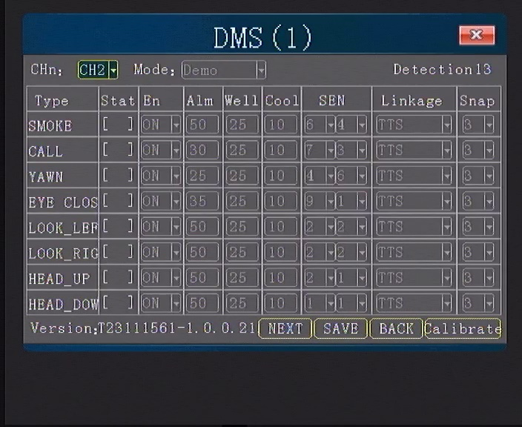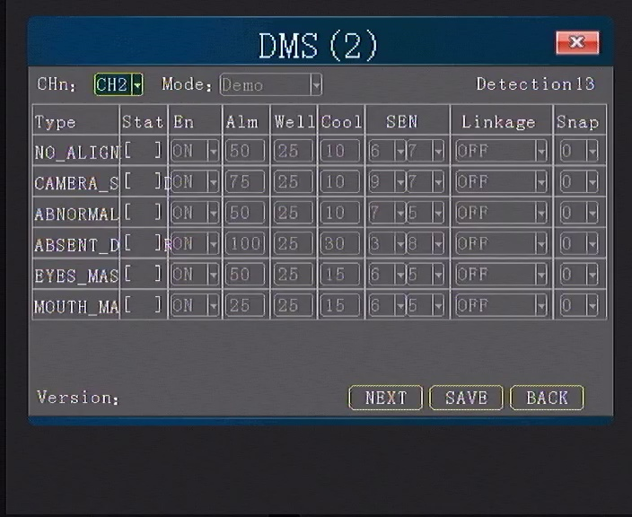

- Mode: Selection of presentation mode and working mode; The default speed in demonstration mode is 0, and in working mode it is 30. When the vehicle's speed exceeds 30, an alarm will be triggered。
- Alarm types: options such as making phone calls, yawning, smoking, closing eyes, covering, distraction, and fatigued driving；
- Sensitivity: Sensitivity to alarm occurrence and sensitivity to return to normal after alarm. 0 is the most sensitive
- Alarm linkage: Output high-level or tts voice when the corresponding alarm occurs
- Recovery/cooling value: After the alarm, the corresponding number of frames collected returns to normal/the cooling ends when the corresponding number of frames is collected
- Photography: Automatically capture the image situation at that time when an alarm occurs；
- Note: The DSM camera is connected to the ch2 channel by default.
ADAS

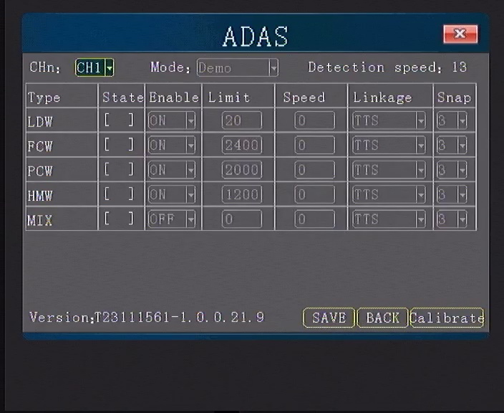

- Modes: Working mode and presentation mode;
- Opening threshold: LDW, lane departure line, unit: cm; Other items, unit: ms
- speed: An alarm will be triggered when the set speed is exceeded
- Type: Lane departure, collision with the vehicle in front, pedestrian collision;
- Alarm linkage: Output high-level or TTS voice when an alarm is generated;
- Taking photos: Automatically capture the image situation at that time when an alarm occurs；

BSD
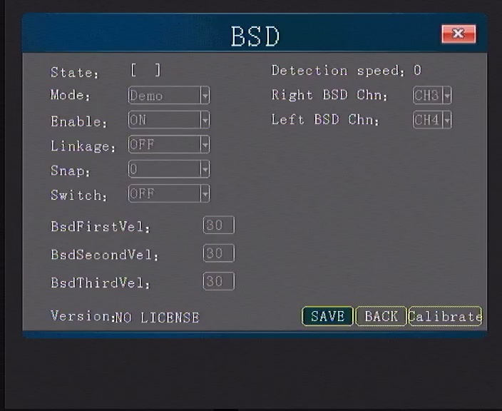

- Mode, working mode and presentation mode；
- Alarm linkage: When an alarm is generated, a high-level or TTS voice is output
- Image capture: Capture images and short videos when blind spot alarms occur
- Alarm screen switching: Magnify a certain channel when an alarm occurs
- Vehicle speed threshold: An alarm will only be triggered when the set speed is exceeded

. Management tools: formatting, configuration management, log query, disk speed, reversing ruler。
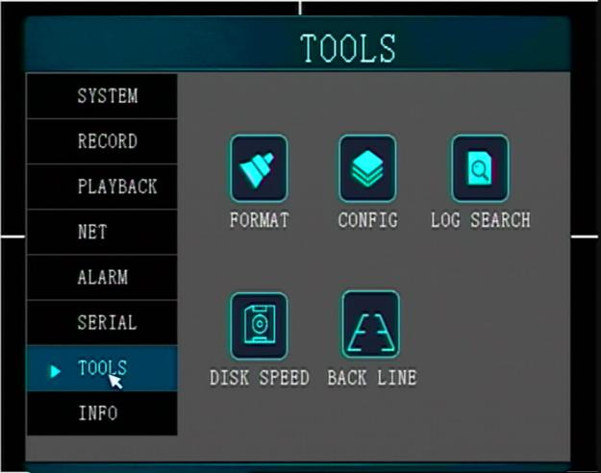

Format: format the video disk
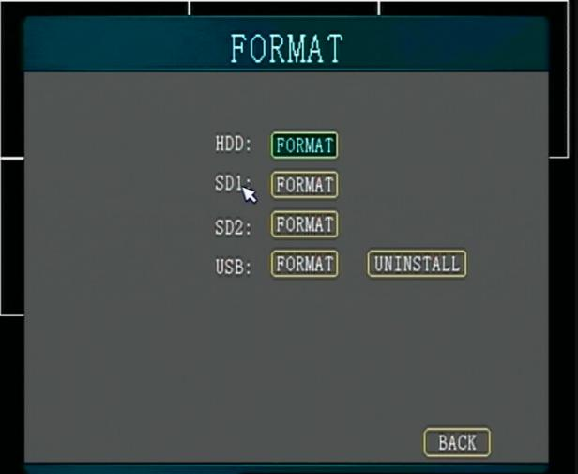

- After formatting, the SD card is in FAT32 format. The disk space and allocation will be performed to reduce the number of disk reads and writes, protect the disk and increase its service life.；
- Important: Formatting will erase the data on the SD card disk数据；

Parameter management:
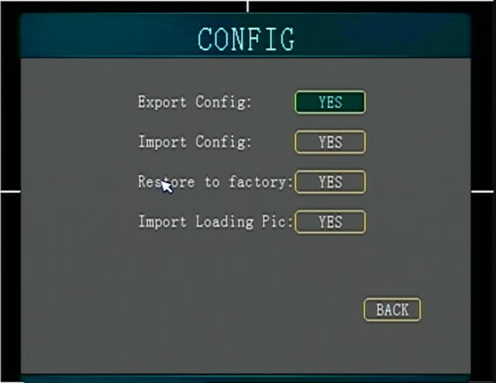

- Parameter export: Export parameter configuration file to SD card or USB, and import this parameter to other devices;
- Parameter import: Import the configuration file from the SD card to the device, the parameters are from the first
- Save default parameters: save the current device parameters as default parameters；

- Restore default parameters: restore current parameters to default parameters;

- Restore factory settings: restore current parameters to factory parameters；Log query：
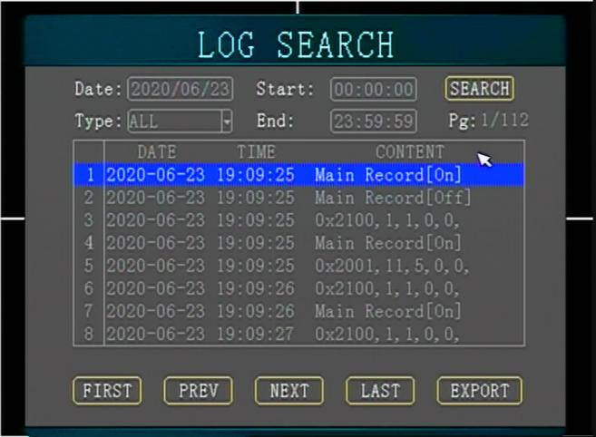
- Start and end time: select search and view logs by entering the time；

- View the host running log through the time display list；

- Move the cursor to the log information, press the [ok] key, if there is a video at the time of this log, it will automatically play the log time video；

isk rate: test the encoding rate of the video disk to determine whether the video disk has bad sectors
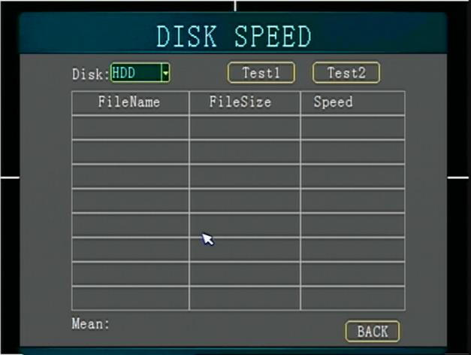

- Disk selection: select the video disk that needs speed measurement.
- Test area: The disk is divided into two areas, the free area is the nand partition, and the recording area is the area where the recording files are located.
- Read and write verification: verify whether the hard disk or SD card is normal.
Reversing ruler: The ruler displayed when reversing.
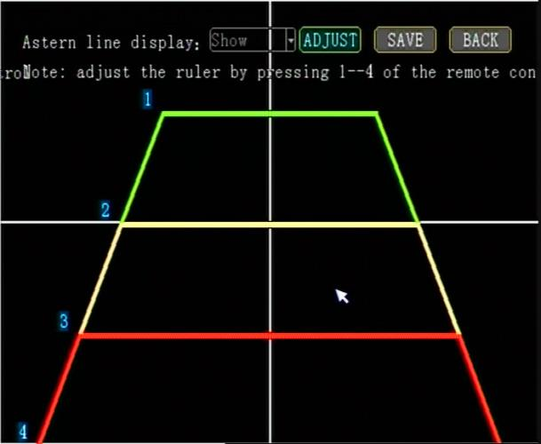
- The first step: the reversing line can be displayed or not displayed; select display, IO alarm enable needs to select reversing
- Step 2: Press adjust to enter the adjustment page, and then press the remote control 1-4 to adjust the ruler up, down, left, and right respectively
- Step 3: After adjusting, press the play button on the remote control to save, or press EXIT on the remote control, and then press save.

INFO：

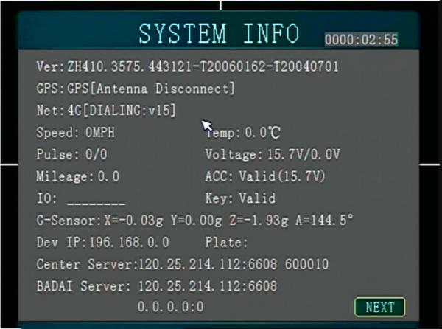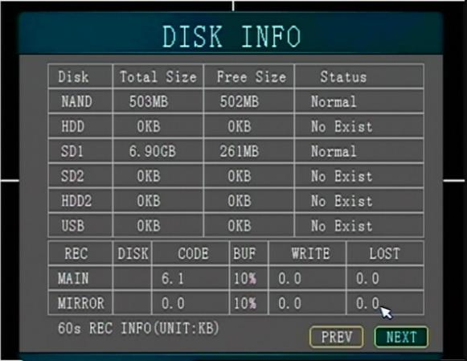

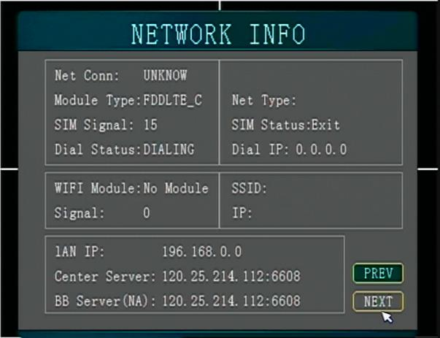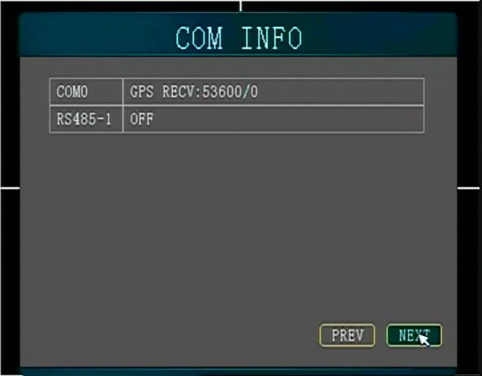

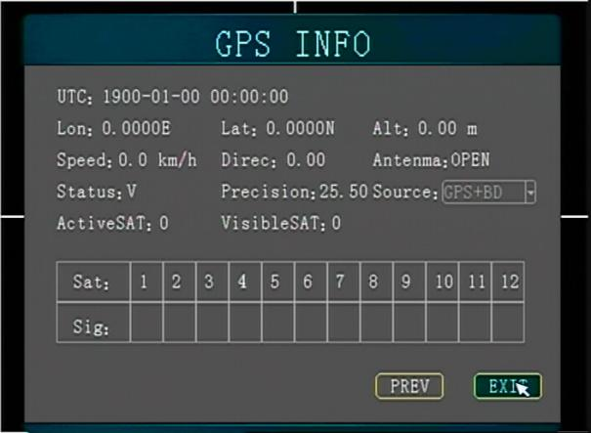 bn

Press the [INFO] key on the remote control in the monitoring screen to quickly call up this page to view modules, central server connection, alarm,
Serial port information, Gps information
System information
Positioning: there are four states: no module, no positioning, no antenna connection or short circuit. Please refer to 4.3 for positioning problems
Network: four states, no module, no dialing, dialing in, dialing successfully. See 4.5 for platform issues

Wiring diagram

5.1 Wiring diagram of HDD video recorder

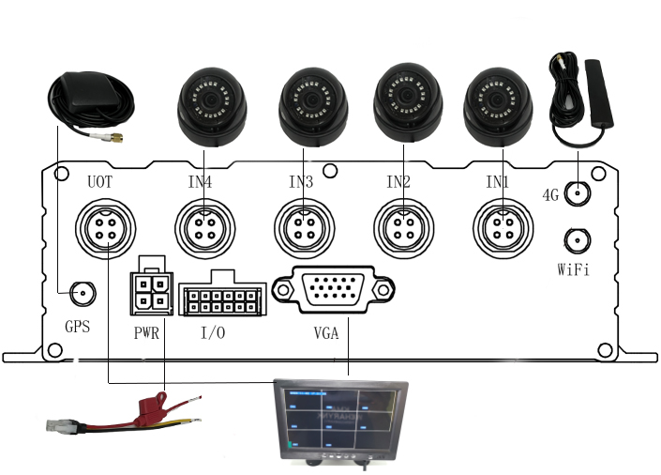

5.2 Quick setting

5.2.1 Wiring test and boot

The power supply of the host has three wires, red, black and yellow. The red and black wires are directly connected to the car battery, the red wire is connected to the positive electrode, the black wire is connected to the negative electrode, and the yellow wire is connected to the ignition wire (ACC). If you test indoors, the red and yellow wires can be connected together. Positive pole, then directly use DC12V power supply,
1. Check that the power cord is connected normally, and confirm that the key block is turned on to the LOCK file after the line is connected, then it will start normally, and the power light will be blue after the normal start.
2. Connect the output line AV-OUT to the display screen and connect the corresponding equipment to the terminal. Confirm whether the connection is correct. The following figure shows the actual installation power supply wiring:：
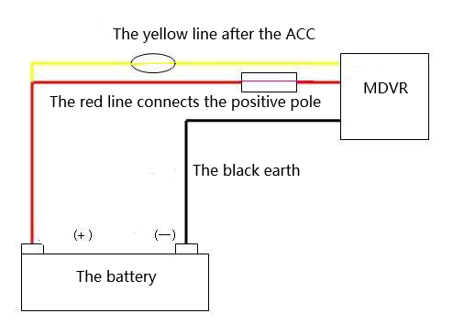

Vehicles quickly report to the server

Note: For hosts without WIFI and 3G module functions, the following descriptions are invalid and do not need to be reported to the platform.
Step 1: Install the SIM card, select the SIM card according to the corresponding module
Step 2: Boot into the system menu, first modify the mobile phone number in the terminal settings (that is the unique ID of the reporting server) and then modify the corresponding license plate number
Step 3: Enter the important network settings, modify the corresponding IP and port number according to the different server deployment IP of each customer, and select the platform of the standard protocol, select the main GPS server on the next page to modify the IP and port number

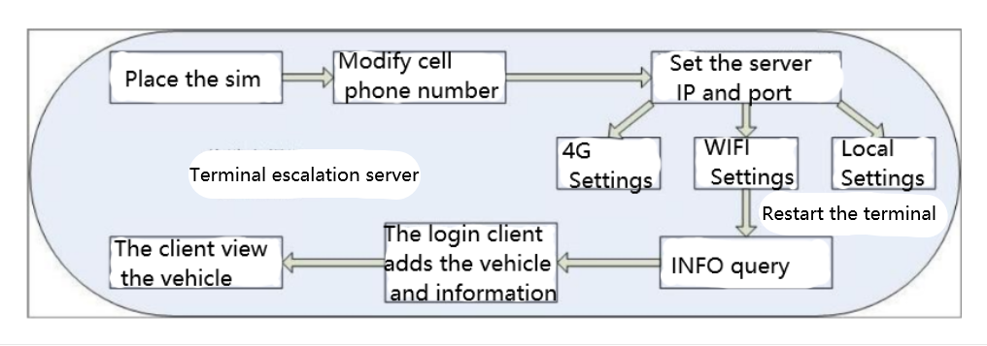

5.2.3 IO serial port use

The device has 4 alarm inputs and 2 alarm output interfaces. The alarm input detection is all level detection, which can be connected to various vehicle driving states, such as brake, steering, vehicle switch, and alarm button, as shown in Figure 4-2. When the brake plate is stepped on, MDVR can
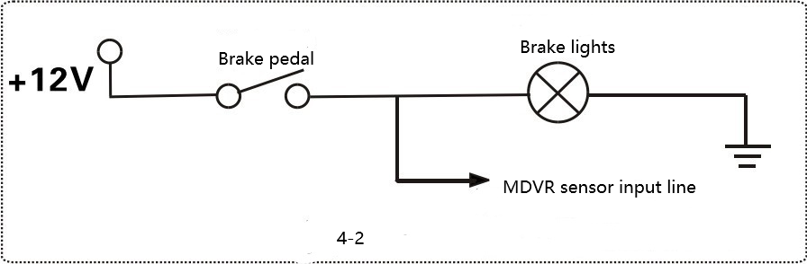
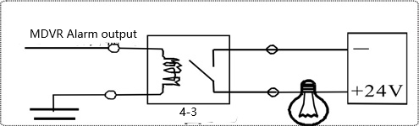
detect the high level, otherwise the low level, the alarm output is all level output, and the drive capacity is 200mA. If you connect a larger power device, you must connect a relay. As shown in Figure 4-3:

5.2.4 PTZ connection and settings

Setting steps:
First,：choose the PTZ protocol: PELCO-D and PELCO-P respectively,
Second：set the baud rate and select it on the terminal according to the corresponding baud rate of the PTZ,
Third：set the address code: directly enter the address code corresponding to the PTZ address value,
Fourth wiring: the 485 control line on the PTZ is connected to RS485-A positive, the other one Connect to RS458-B negative

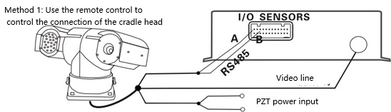

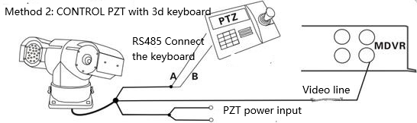

Related issues and solutions

6.1.1 Why doesn't it record video after the device is turned on

- Please check if there is HDD in the device, system information-next page of disk and video information.
- Check the recording setting-storage setting, whether the main recording in the use column is SD or HDD.
- Please check the recording settings-the main stream setting, whether the main recording is on.

Why does the device often restart when installed in the car？

- . Frequent restarting occurs: the device repeatedly goes online and offline; the recording is intermittent and not continuous

- . Causes of frequent restarts:

a. The power supply of the vehicle is unstable. Please measure the input voltage of the device when there is a problem with the device. The probability of frequent restart of the device due to this situation is relatively common in actual applications
b. The storage disk fails, format the storage disk or replace the storage disk under the premise of preserving data
c. Device software or hardware problems, please remove the storage device hard disk or SD card, and the device still restarts when the power supply to the device is normal. Please inform the technical support staff of the software version number, and return to the factory for repair if necessary

6.1.3 Why does the display not produce images

①. Check the equipment video Settings - basic Settings - whether the camera resolution is the same camera used.

② .If there is no video out of a channel, switch the camera position, restart it if necessary, and check whether there is a problem with the camera or the channel.
- .If the VGA screen is good, but the blue screen is displayed and the indicator light of the device is normally flashing or always on, you can change the AV screen to check whether the display resolution of the video setting - basic setting is 1024*756, or if the platform is online, you can modify this parameter remotely

6.1.4 Why can't you watch the video on the platform?

①.First make sure that the device is online, the general device number shows green or red, if gray is offline.
② check the network signal is good, the system information (INFO key) to see the network dial value.
- If the connection is to the ministry platform, check whether the terminal setting - mobile phone number and the platform fill in the same, network setting - label server -IP port and the ministry protocol must choose 1078.
- The server is in maintenance or stop working, contact the platform staff.

6.1.5. Why is there no video

① First, make sure the SD card or hard disk exists, press the INFO key of remote control -- the next page of disk and video information, you can see whether the video disk exists, whether it is writing (that is, the video), whether the video is lost,
② Check the video Settings - The basic Settings choose boot video or timed video,

6.2 GPS Related questions

6.2.1 Why can't I see GPS location information on the device？
- Check whether the module status on the device exists,
- If it does not exist, check the peripheral management-serial port settings-como peripherals select GPS reception.
- Check whether the GPS antenna is connected properly. The antenna must be placed in a wide and unobstructed place to get the signal. When a vehicle passes through a tunnel or is blocked by tall buildings or trees, it will not receive the signal. This situation is normal Phenomenon,
- The GPS antenna is placed horizontally, preferably outside the car, away from the electronic equipment。

6.2.2 The device is online, why can't I see the vehicle location information?？

- . Please check the GPS upload time interval set on the platform

- . The GPS signal on the device is received normally to upload valid positioning information to the platform, so please check the GPS on the device Whether the signal is displayed normally

6.3 4G Dialing problem

4G Unsuccessful dialing？
① View module status, dial parameter settings
② Check whether the antenna is connected properly, and the 4G signal strength
③ Check the status of the SIM card, whether the SIM card has the Internet access function, if you need to make a call, you need to enable the voice function; and the charging status, whether there is arrears

Platform server connection related issues

Why can't the device be connected to the platform server
① To connect to the platform server through 3G/4G, the 3G/4G dialing must be successful, please confirm that the 3G/4G module has dialed successfully
② Check whether the server IP and port set on the device are correct, and whether the reported ID conflicts
- Is the back-end server operating normally? Is there any other vehicle online?

6.5 Host software local upgrade instructions

①. Copy the upgrade file to the SD card or USB flash drive, insert the SD card or USB flash drive into the device, power on the device, it will automatically upgrade after successful startup, and automatically restart after the upgrade is complete. Check the version number in the system information interface after restarting.
②. Note: Do not power off the device during the upgrade process. The SD card or hard drive that is first put into the device is formatted once

